1. General information

Name of the installation
Sales partner
Contact person at the client

2. Set-up of a new installation

Contact person on-site (PC)
Contact person on-site (recorder)

Recorder – ISDN Data

IP address | Remote address | Telephone number | User | Password

Recorder – LAN Data

IP address | Subnet mask | Router

PView PC -Data

IP address RAS service | ISDN telephone number | User name | Password
Beginning

End

IP address LAN | Subnet mask LAN | Gateway Router

Router - Data

ISDN number | User name | Password

3. Modifications of an already existing installation

Contact person on-site (PC)
Contact person on-site (recorder)
Model and type of recorder
Recorder with ISDN-card | Yes No
Model and type of router

Recorder – ISDN Data

IP address | Remote address | Telephone number | User | Password

Setup / Network / Settings / ISDN

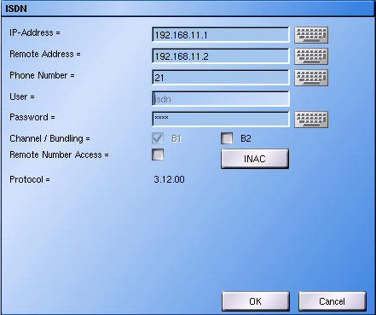

Recorder – LAN Data

IP address | Subnet mask | Router

Setup / Network / Settings / Ethernet/Tokenring

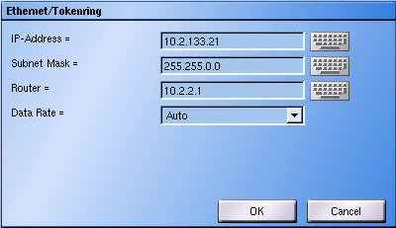
PView PC -Data

IP address RAS service | ISDN telephone number | User name | Password
Beginning

End

IP address LAN | Subnet mask LAN | Gateway Router

Router - Data

ISDN number | User name | Password

